Ideation Phase
Empathize & Discover

Date | 25 June 2026
Team ID
Project Name | SB Stocks – Paper Trading Platform
Maximum Marks | 4 Marks

User Persona

Name
Beginner Investor / College Student

Age
18–30 Years

Occupation
Student / Beginner Investor

Goal
To learn stock market trading without risking real money.

Empathy Map Canvas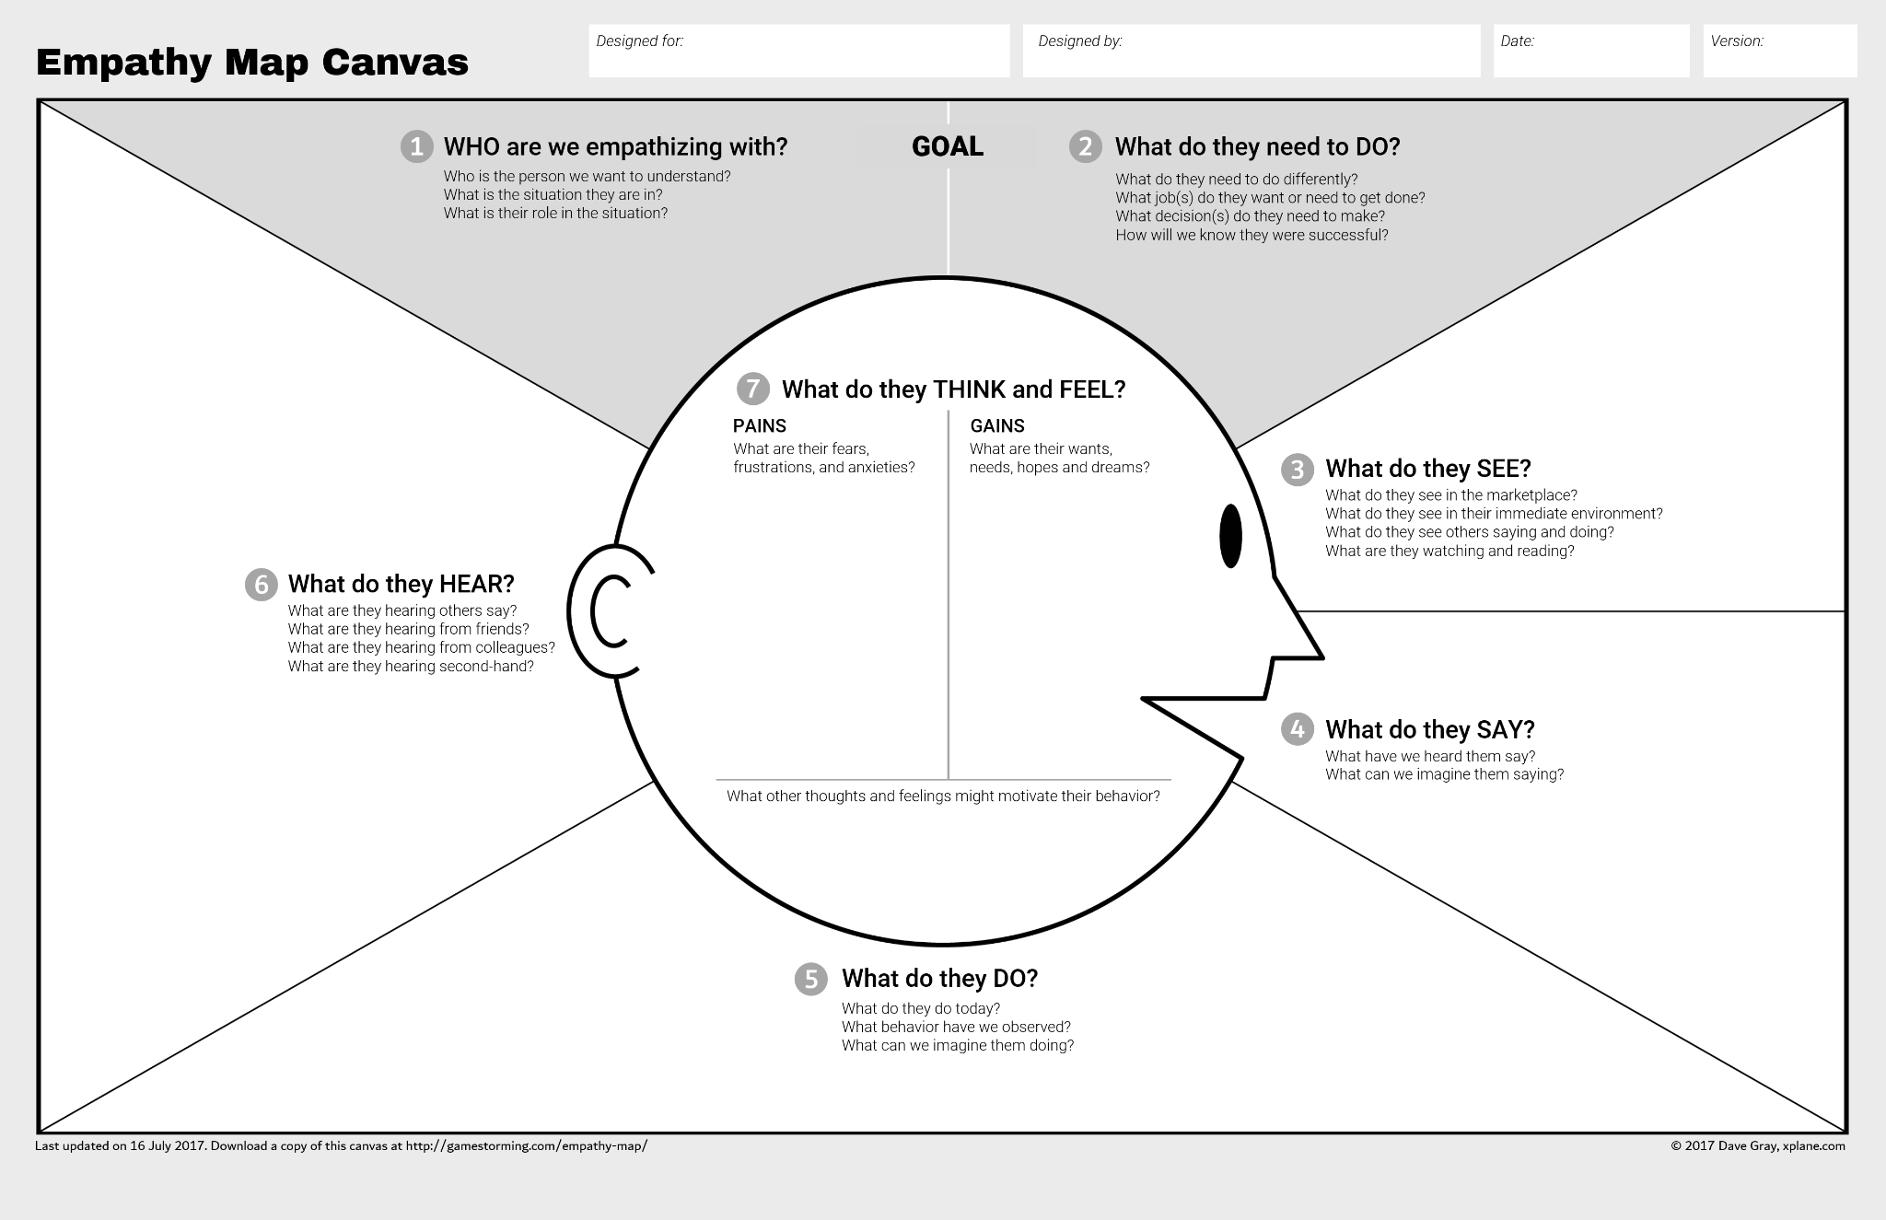

SAYS 💬 | THINKS 💭
"I want to learn how stock trading works." | "What if I lose money in real trading?"
"I need a simple platform to practice." | "Can I gain experience before investing?"
"I don't know how to buy or sell stocks." | "I hope this platform is secure and easy to use."
"I want to improve my investment knowledge." | "I should understand the stock market before using real money."

DOES 🚀 | FEELS ❤️
Registers an account. | Curious about stock trading.
Logs into the application. | Nervous about making mistakes.
Views available stocks. | Excited to buy virtual stocks.
Buys and sells stocks using virtual money. | Happy after completing successful trades.
Checks portfolio and transaction history. | More confident in learning investment strategies.

PAINS 😟
- Fear of losing real money.
- No practical stock trading experience.
- Difficult-to-use trading platforms.
- Lack of confidence in investment decisions.
- Limited knowledge of stock market concepts.

GAINS 🎯
- Risk-free stock trading experience.
- Practical understanding of buying and selling stocks.
- Improved financial literacy.
- Confidence before investing in real markets.
- Easy portfolio and transaction management.
- Secure and responsive web application.

User Needs
- Secure login system.
- Beginner-friendly interface.
- Virtual money for practice.
- Portfolio management.
- Transaction history.
- Fast and responsive application.
- Easy navigation.

Solution Offered by SB Stocks
The SB Stocks – Paper Trading Platform fulfills these needs by providing:
- ✅ User Registration & Login
- ✅ JWT Authentication
- ✅ Virtual Stock Trading
- ✅ Portfolio Management
- ✅ Transaction History
- ✅ Responsive Dashboard
- ✅ Cloud Deployment using Vercel & Render

Expected Customer Experience
The user can safely explore stock market concepts, practice investment strategies, monitor portfolio growth, and gain confidence without risking real money. This creates a positive learning experience and encourages financial awareness.

